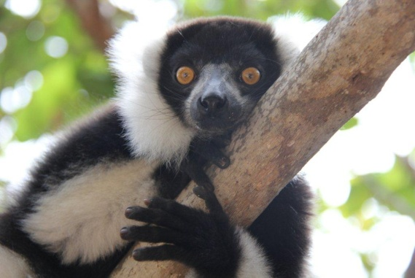
LEMUR VISITS

RELEASE OF LIABILITY

- I, the undersigned, hereby acknowledge that I have voluntarily applied to, or for my child(ren) to, visit the lemurs which are kept by Necker Island BVI Limited (Necker) and to go into the lemur enclosure to see them at close proximity.

- I confirm that I am fully aware that the lemurs constitute a potential danger to persons entering their enclosure, whether or not with a member of Necker staff. I understand that there are inherent risks to persons in close proximity to lemurs, including, but not limited to: personal property damage, bodily injury including but not limited to cuts, abrasions, bites, communicable diseases, or death.

- I am also fully aware and have been advised that visitors should not enter the lemur enclosure unless accompanied at all times by a member of Necker Staff who is experienced and trained in the care of lemurs, and all visitors are required to follow orders given at any stage by the accompanying member of Necker staff because such orders will be made for the purpose of protecting the visitors’ personal safety.

- I permit the appropriate staff or representatives of Necker to seek medical assistance for me or my child(ren) if required, recognizing that Necker, and any person involved with Necker, does not assume responsibility for, nor do they have any liability for, the medical assistance and care which may be so selected and provided.

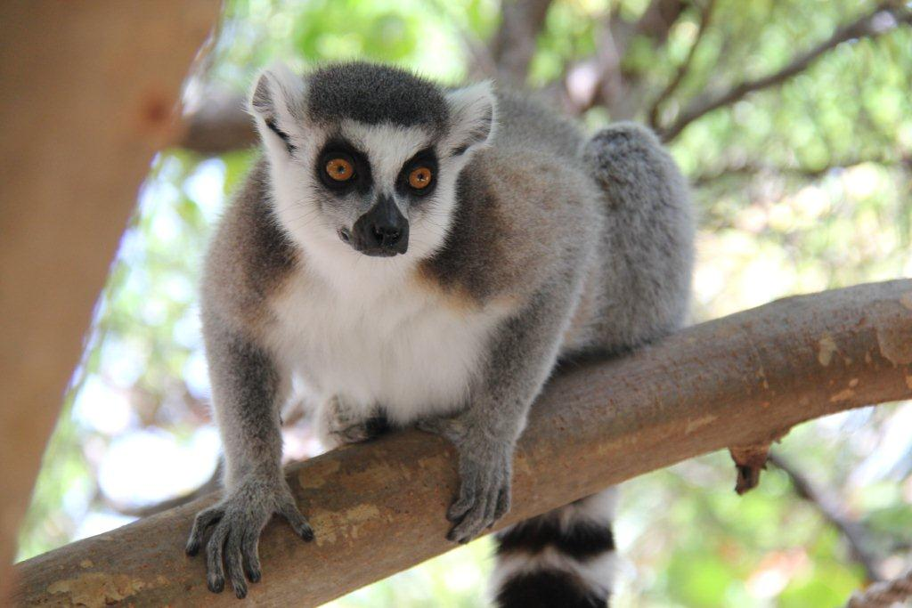

- In consideration of me and/or my child(ren) being permitted to visit the lemurs and enter into their enclosure, I hereby release and undertake and agree to hold Necker harmless, and its holding and associated companies, employees officers, agents and representatives (the Released Parties), to the fullest extent permitted by law from any claim or lawsuit whatsoever arising out of damage, loss or injury to me, my child(ren), our property, or my, or my child(ren)’s, death as a result of our/their presence in the lemur enclosures, whether caused by the negligence, active or passive, of the Released Parties or from any other cause.

- I confirm that I am of lawful age and legally competent to sign this release on my own behalf and/or on the behalf of my child(ren) and that I have signed this release voluntarily and with the knowledge that I hereby contract to waive my legal rights and those of my child(ren). I also agree that if any provision of this release is unenforceable, the remaining provisions shall remain in full force and effect as though the unenforceable provision had never been present.

Participant (over 18 years of age)

Full Name: ______________________________

Signature: ______________________________ Date:

Parent/Guardian Consent

Parent/Guardian Full Name: ______________________________

Signature: ______________________________ Date:

Children’s Full Names

1. ______________________________ 2. ______________________________

3. ______________________________ 4. ______________________________

